T

TIBCO BusinessEvents: Enums & Switch-Case

Product Suite | TIBCO BusinessEvents
Product | BE
Product Version | 5.x
Initial Author | Pranab Dhar

Copyright Notice
COPYRIGHT© 2009 TIBCO Software Inc. This document is unpublished and the foregoing notice is affixed to protect TIBCO Software Inc. in the event of inadvertent publication. All rights reserved. No part of this document may be reproduced in any form, including photocopying or transmission electronically to any computer, without prior written consent of TIBCO Software Inc. The information contained in this document is confidential and proprietary to TIBCO Software Inc. and may not be used or disclosed except as expressly authorized in writing by TIBCO Software Inc. Copyright protection includes material generated from our software programs displayed on the screen, such as icons, screen displays, and the like.
Trademarks
Technologies described herein are either covered by existing patents or patent applications are in progress. All brand and product names are trademarks or registered trademarks of their respective holders and are hereby acknowledged.
Confidentiality
The information in this document is subject to change without notice. This document contains information that is confidential and proprietary to TIBCO Software Inc. and may not be copied, published, or disclosed to others, or used for any purposes other than review, without written authorization of an officer of TIBCO Software Inc. Submission of this document does not represent a commitment to implement any portion of this specification in the products of the submitters.
Content Warranty
The information in this document is subject to change without notice. THIS DOCUMENT IS PROVIDED "AS IS" AND TIBCO MAKES NO WARRANTY, EXPRESS, IMPLIED, OR STATUTORY, INCLUDING BUT NOT LIMITED TO ALL WARRANTIES OF MERCHANTABILITY OR FITNESS FOR A PARTICULAR PURPOSE. TIBCO Software Inc. shall not be liable for errors contained herein or for incidental or consequential damages in connection with the furnishing, performance or use of this material.
For more information, please contact:
TIBCO Software Inc.
3303 Hillview Avenue
Palo Alto, CA 94304
USA
Table of Contents
TIBCO BusinessEvents: Enums & Switch-Case 1
1 Change Log 4
1.1 Related Documents 4
2 Introduction 5
2.1 Main Objective 5
2.2 Intended Usage 5
2.3 Scope 5
2.4 Audience 5
3 Acronyms and Vocabulary 6
4 Enum 6
4.1 Enum - Editor 7
4.2 Enum – EMF 8
4.3 Enum – Usage 9
4.3.1 Control statement 9
4.3.2 Assignment 10
4.3.3 Typed variable 10
4.3.4 Mapper 11
4.3.5 Query 11
4.3.6 DBConcepts 11
4.3.7 Decision Table Domain Mapping 12
5 Switch-Case control statement 12
5.1 Usage 12
5.2 Core Model 12
5.3 Rule Editor 12
5.4 Rule Compiler 12
5.5 Code Generation 12
5.6 Rule Debugger 13

Change Log
.
Date | Version | Name | Description
02/17/2011 | 1.0 | Pranab Dhar | Initial doc

Related Documents
Document Title | Revision Number | Author

Introduction

Main Objective
The objective of this document is to outline the requirements of the BE rule language enhancement supporting Enumerations and switch/case constructs.

Intended Usage
BE rule language users are the primary beneficiaries of this enhancement. The BPMN code generation which will generate BE code is the target beneficiary. BPMN will be used by different types of users. These users include: Business Owners, Business Analysts, Developers, IT Engineers.

Scope
The scope of this document is to provide an overview of what we would like to achieve in the initial BE rule language enhancement to support Enumerations and Switch/Case branching.

Audience
The document is intended for Developers, Architects, QA, Product Marketing, and Managers.

Acronyms and Vocabulary

The table below describes some of the Acronyms used in this documentation
- BE – TIBCO BusinessEvents.
- Studio Project – A TIBCO Project build using TIBCO BusinessEvents Studio.
- BPMN – Business Process Model Notation
- Enum - Enumeration

Enum
Enumerations define a set of named constant values e.g. Color.RED, Color.BLUE. It defines a typed domain in which the values are distinct and well defined.
The enumeration in BE will have defined values and each value can have multiple attributes. The enum values can be illustrated as <EnumType Name>.<EnumValue> and enum value attributes illustrated as <EnumType Name>.<EnumValue>@<Enum Attribute>. E.g. Enum for AirportCode
TypeName/Attribute | @id(long) | @code(String) | @city(String) | Usage
SFO | 1 | SFO | San Francisco | AirportCode.SFO
JFK | 2 | JFK | New York | AirportCode.JFK
SJC | 3 | SJC | San Jose | AirportCode.SJC

The enumeration value in BE can have one fixed attribute @id and other user defined attributes also referred as @<name>. e.g.Enum AirportCode has attributes
# | Attribute Name | Type | Desc | User Defined | Default | Usage
1 | id | Long | Default enum value id | No | Yes | @id
2 | code | String | Airport Code | Yes | No | @code
3 | city | String | City | Yes | No | @name

Enum - Editor

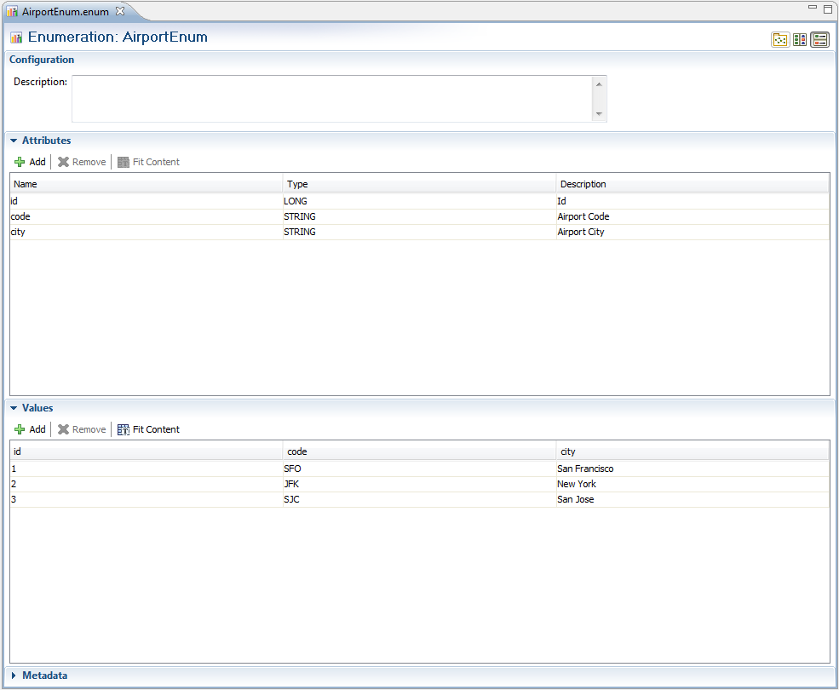

An alternative to creating a new enum type would be using existing notion of “Domain Model”.
Domain Model is a collection of data values belonging to certain data type and can be presently associated with concept/event properties for a certain data type. Domain Models have support for inheritance.
Domain Models can be expanded to support enum like construct. We could augment domain model for supporting multiple user defined attributes, or have different domain model for each such enum. E.g : In above case, city will be in one domain model “City” while airport code could be another Domain Model “Airports”.
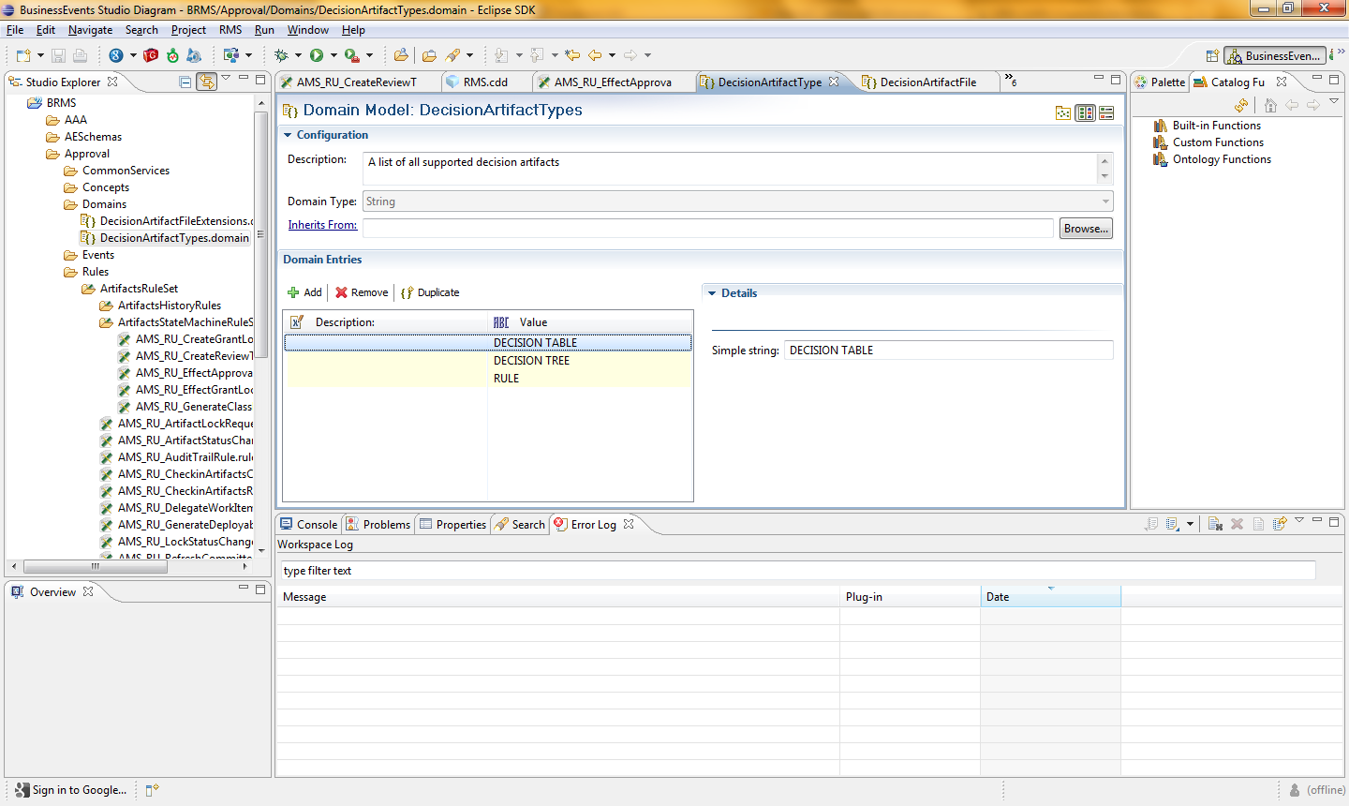

The enum appears in the ProjectExplorer under its own extension

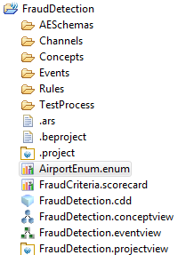

Enum – EMF
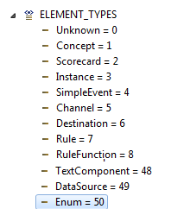

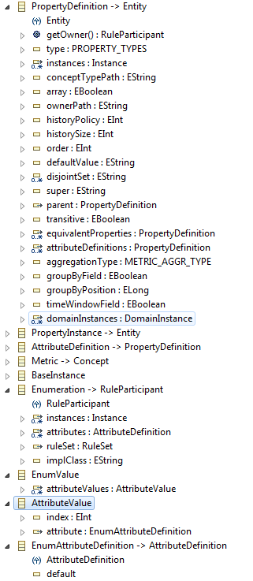

Enum – Usage

The enumeration can be used in BE as follows

Control statement
Int airport;

If(airport == Airport.SFO@id) {
}

String airportCode;
If(airportCode == Airport.SFO@code) {
}

// new control statement
String airportCode;
Switch(airportCode) {
Case Airport.SFO@code:
Break;
Case:Airport.SFO ⬅ auto match the type of the airportCode with the enum attribute type
Break;

}

Int airportId
Switch(airportId) {
Case Airport.SFO@id:
Break;
Case:Airport.SFO ⬅ auto match the type of the airportCode with the enum attribute type
Break;

}

Assignment
String x = Airport.SFO@code;
int I = Airport.SFO

Typed variable

Airport a;

If( a == Airport.SFO ) {
}

Mapper
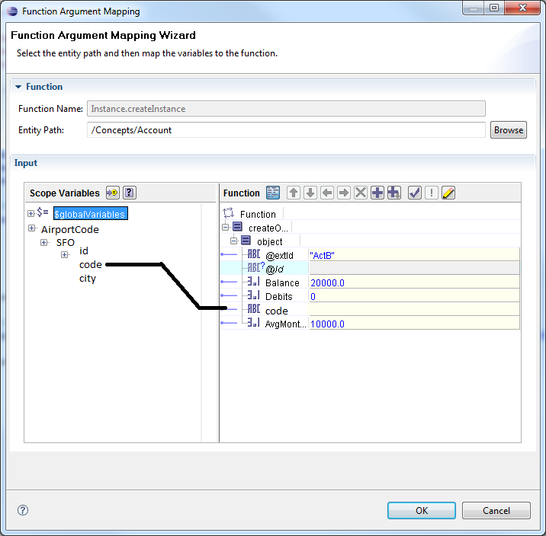

Query

Select <projection> from Airports x where x.code = EnumAirport.SFO;

DBConcepts
A code table which usually consists of unique static data can be mapped to a Enum.
id | code | city
1 | SFO | San Franscisco
2 | JFK | New York
3 | SJC | San Jose

Decision Table Domain Mapping

Switch-Case control statement
The switch case control statement is derived from java like language to allow the value of a variable or expression to control the flow of program execution via a multiway branch. The main reasons for using a switch include improving clarity, by reducing otherwise repetitive coding, and (if the heuristics permit), offering the potential of faster execution through compiler optimization.

Usage
The switch-case control statement can be used in the rule language only. The syntax is as follows :

Switch(expression) {

Case constantValue1:
expressions
Break;
Case constantValue2:
expressions
return;
Default:
Break;
}

Expression := variable | function f(a,b,c)

constantValue = String Constant | Int constant | long constant | double constant | char constant | Enum value;

Core Model

Rule Editor
Rule AST/Antlr
Syntax Validation

Rule Compiler
JavaCC Parser

Code Generation
Class/Enum generation
Line Mapping

Rule Debugger
Debug execution

